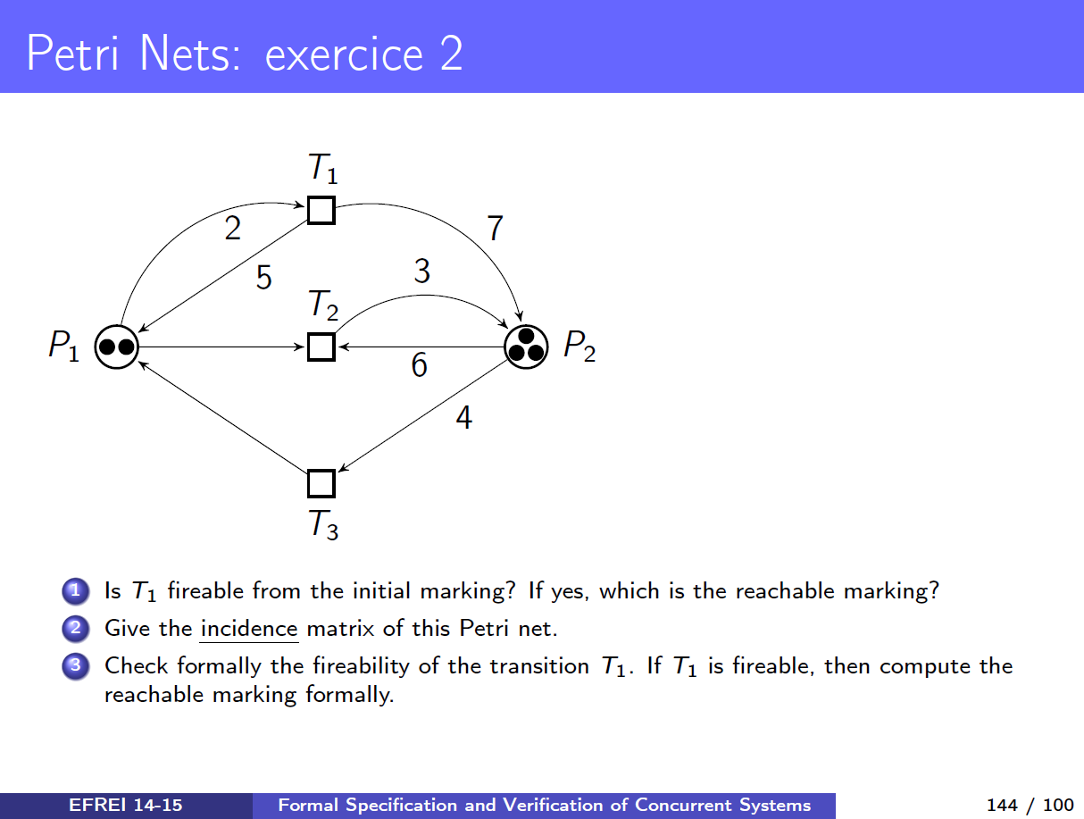

Question 1) Is T1 firable from the initial marking ?
Yes, T1 is fireable: P1 → T1 can be fired because m(P1) = 2 and PRE.t1(P1, T1) require 2.
Reachable marking = M1, when T1 fired.
M0 = { 2, 3 } // Order: Mn = { P1-tokens, P2-tokens }
M1 = { 5, 10 }

Question 2) Give the incidence matrix C
PRE
 | T1 | T2 | T3
P1 | 2 | 1 | 0
P2 | 0 | 6 | 4

POST
 | T1 | T2 | T3
P1 | 5 | 0 | 1
P2 | 7 | 3 | 0

Incidence matrix C
 | T1 | T2 | T3
P1 | 3 | -1 | 1
P2 | 7 | -3 | -4

The Incidence matrice C is defined by
C(P1, T1) = POST(P1, T1) - PRE(P1,T1) = 5 - 2 = 3
C(P2, T2) = POST(P2, T2) - PRE(P2, T2) = 3 - 6 = -3

Question 3) Check formally the fireability of the transition T1. If T1 is fireable, then compute the reachable marking formally.

